Date: 28/02/2025

EXPERIMENT-13

DESIGN THE FUNCTIONALITIES AND EXPLORATION OF TCP USING PACKET TRACER

Aim: To design the Functionalities and Exploration of TCP using Packet Tracer.
Software/Apparatus required: Packet Tracer/End devices, Hubs, connectors.
Procedure:
Step 1: Setup the network topology
To begin, we will create a simple network topology consisting of two computers connected by a router. Open Packet Tracer and drag two PCs and a router onto the workspace. Connect the two PCs to the router using Ethernet cables.
Step 2: Configure IP addresses
Next, we will configure IP addresses for the computers. Double-click on each PC to open the configuration window and navigate to the Desktop tab. Click on the IP Configuration icon and enter the IP address and subnet mask for each computer. For example, PC1 can have an IP address of 144.144.144.4 with a subnet mask of 255.255.0.0and PC2 can have an IP address of 144.144.144.8with the same subnet mask.
Step 3: Configure the router
Now, we will configure the router. Double-click on the router to open the configuration window and navigate to the CLI tab.
COMMANDS:
enable configure terminal interface FastEthernet0/0
ip address of 144.144.144.4255.255.0.0 no shutdown
exit
exit
Step 4: Test the connection
Now that the network is set up and configured, we can test the connection between the two computers. Open a command prompt on PC1 and ping PC2 by typing ping 192.168.1.2 in the command prompt. If the ping is successful, it means that the two computers are communicating with each other.
Step 5: Explore TCP functionalities
Now, let's explore the functionalities of TCP. We will use the Netcat utility to establish a TCP connection between the two computers. Netcat is a versatile networking tool that can be used for various purposes, including establishing TCP connections.
Diagram:
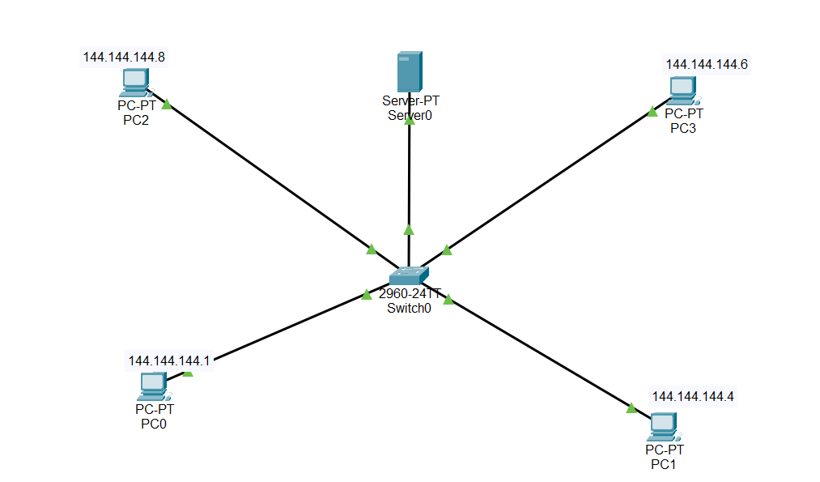

Output:
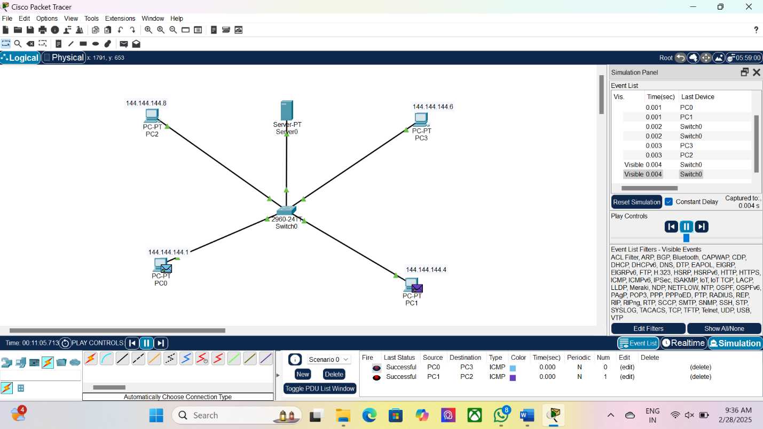

Result: Thus the Functionalities and Exploration of TCP using Packet Tracer is designed successfully.

